**GUJARAT TECHNOLOGICAL UNIVERSITY**

Chandkheda, Ahmedabad

Affiliated

**S. S. Agrawal Institute of Engineering**

**& Technology**

An

Internship report on

**“Food Website using Flask”**

Under the course of

**SUMMER INTERNSHIP**

(SUBJECT CODE:4330001) D.E. II, Semester – III

(Diploma Computer Engineering)

Submitted by:

|  |  |  |
| --- | --- | --- |
| SR. | Enrollment No. | Name |
| 1 | 224590307024 | Nadar Nitesh Kumar Palraj |

PROF. Faculty Name

(Faculty Guide)

PROF. Brijesh Bhandari

(Head Of The Department)

Academic year

(2024-2025)

**CERTIFICATE OF AUTHENICITY**

**S. S. AGRAWAL INSTITUTE OF ENGINEERING & TECHNOLOGY, NAVSARI**



This is to certify that the “Internship Report” submitted by _________________________ (Enrollment No. : __________________) is work done by her and submitted during 2023-2024 academic year, in partial fulfillment of the requirements of Diploma Engineering in Computer Engineer department.

Internal Examiner External Examiner

Faculty Guide Head Of Department

### CERTIFICATE OF INTERNSHIP

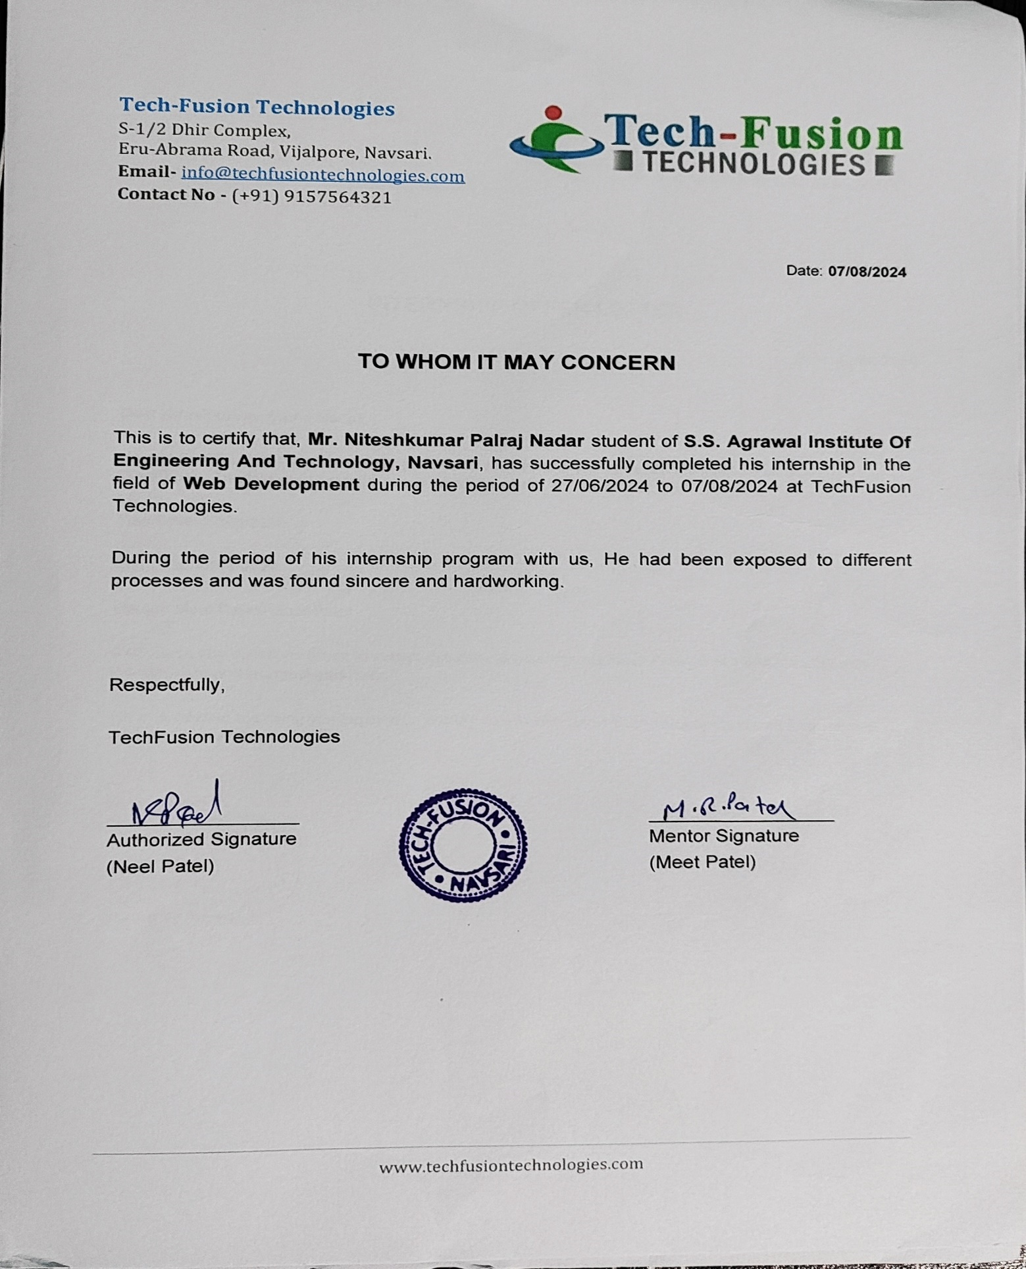

**ACKNOWLEDGEMENT**

I am happy that I have successfully completed my internship but it would be incomplete without the names of the people who have helped me to achieve this milestone, I would like to extend my heartiest thanks with deep sense of gratitude and respect to all those who provide me imminence help and guidance during my internship.

I would like to express my deep sense of gratitude to **Dr. (Prof.) Dipesh Shukla**, **Principal, SSAIET, Navsari,** for his continuous effort in creating a competitive environment in our college and encouraging throughout this course.

I would like to express my sincere thanks to **Prof. Brijesh Bhandari, Head of the Department, SSAIET, Navsari** for his continues encouragement, motivation throughout the internship program.

A special thanks to my mentor during this internship program **Prof. _______________________________, SSAIET, Navsari,** for overall directions, suggestions and encouragement.

I would also like thank the platform that helped me to do the online internship, (Company Name), for their support , availability, and insightful comments and for steering me to the right direction whenever I needed it .

I am grateful to thank all those who I had the pleasure to learn with for with for making this demanding time joyful yet efficient, and for taking the time to answer any of my questions.

Finally I must express my very profound gratitude to my parents for providing me with unfailing support and continuous encouragement throughout my years of study leading to this very moment and particularly for their sacrifices.

**ABSTRACT**

This report describes my internship experience at Tech-Fusion Technologies , and it is divided into three chapters. Chapter One summarizes about the organization in which I am doing the internship. It also includes the mission and vision of Tech-Fusion Emerging Technologies Pvt.Ltd, Department and Team under which I am doing my internship work.It describes the features, purpose and motivation that the Organization provides. Chapter 2 summarizes the hardware and software requirements utilized during my project. Chapter 3 provides the background and purpose of the tasks that were assigned to me, which included various Platforms.It describes the process I used to complete my project. It explains how this task contributed to my development as a Computer Science and Engineering student.

**LIST OF CONTENT**

|  |  |  |
| --- | --- | --- |
| **Sr. No.** | **Topic** | **Page No.** |
| 1. | Company Profile |  |
| 2. | Project Overview |  |
| 3. | Outcomes |  |
| 4. | Conclusion |  |
| 5. | References |  |

**Company Profile**

**Company Name:** Tech-Fusion Technologies

**Address:** S-1/2 Dhir Complex Opposite Samarpan Sadhak Nivas, Eru-Abrama Road, Vejalpore,Navsari,Gujarat 396445

**Website :** www.techfusiontechnologies.com

**Email :** info@techfusiontechnologies.com

**Phone:** 9157564321

**Project Overview**

* App.py

**Website Preview**

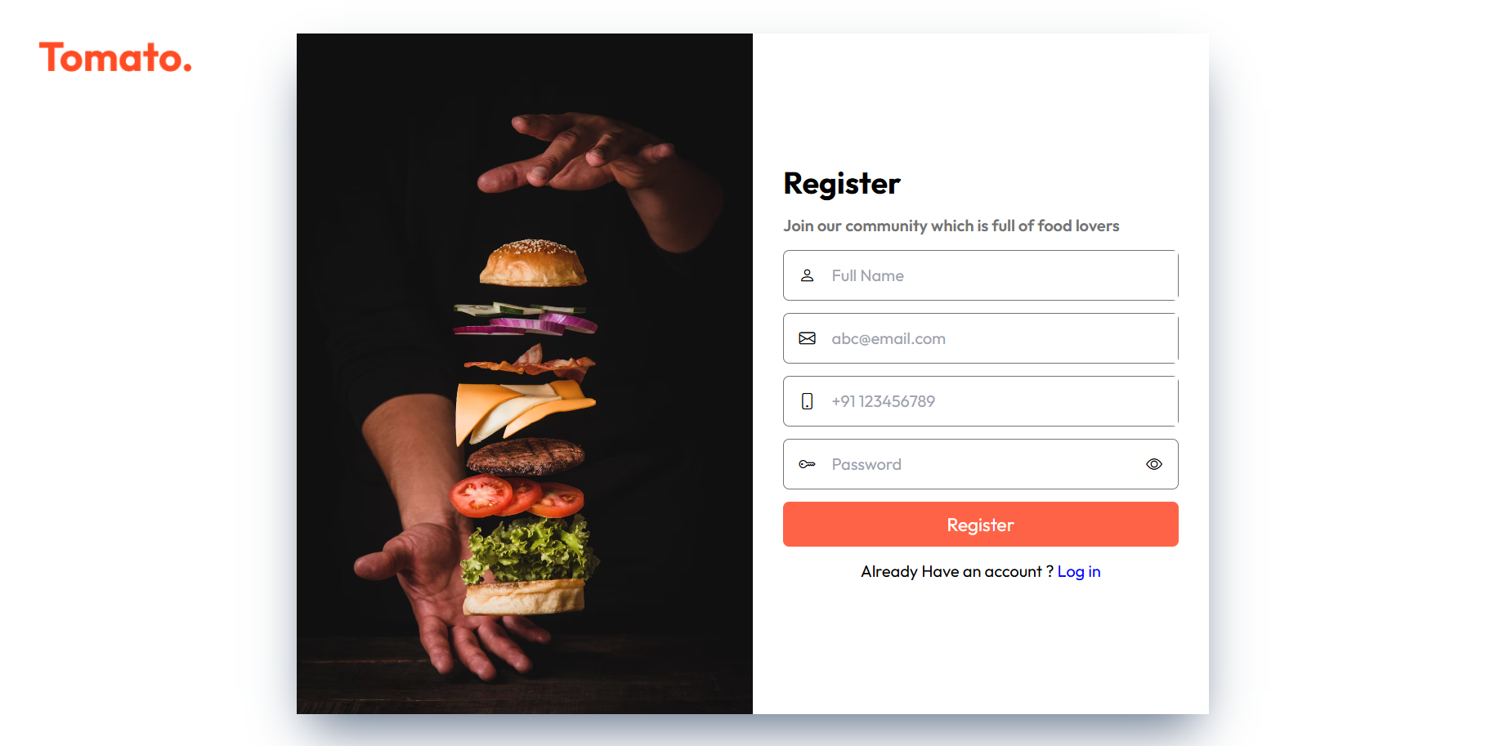

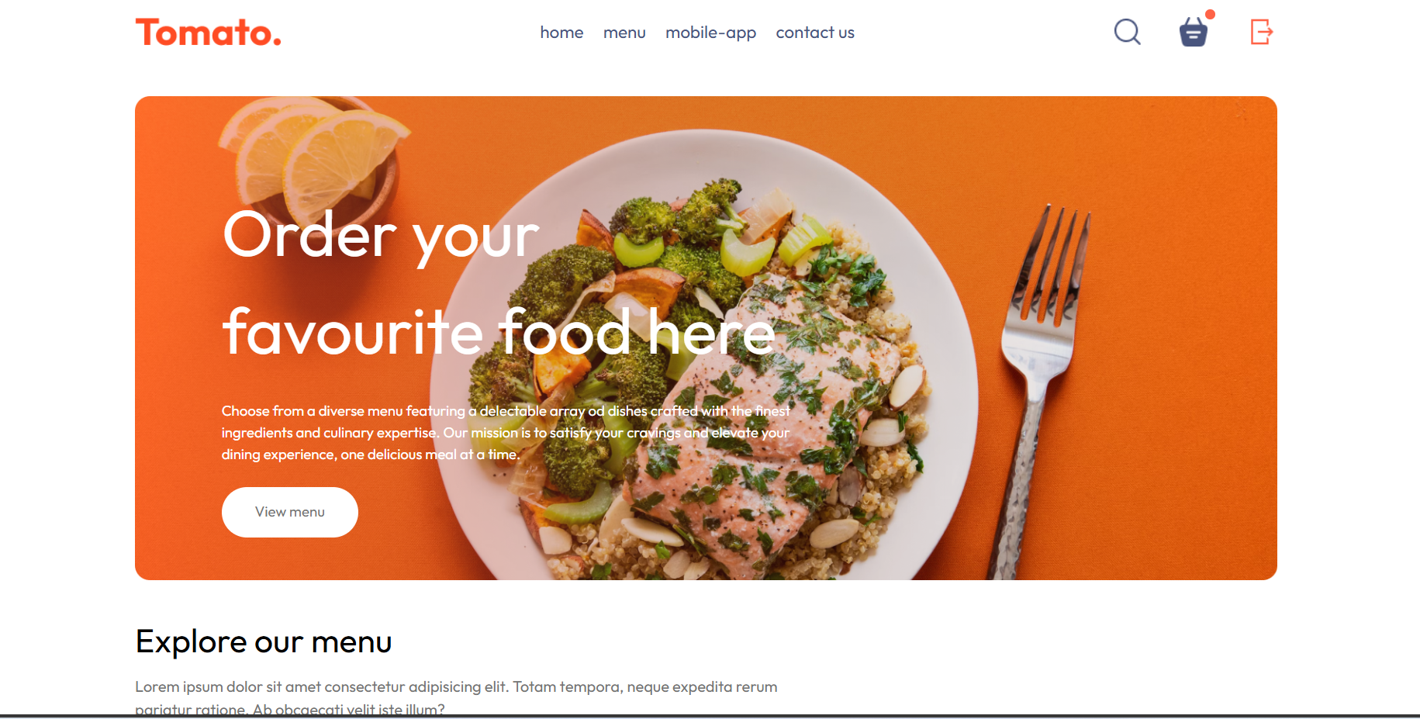

**­**

**Conclusion**

The work experiences I encountered during the internship at Techfusion technologies allowed me to develop my coding skills. I think I still require to work on my problem solving skills. But, the overall experience was great, and everything I learned would be useful in my future career in this field.

**References**

* PYTHON References

Tutorial points: https://www.tutorialspoint.com/flask/index.html